Selenium preparation:

Selenium is one of the most widely used open source Web UI (User Interface) automation testing suite.

Selenium WebDriver is the most important component of Selenium Tool's Suite.

WebDriver has a built-in implementation of Firefox driver (Gecko Driver). For other browsers, you need to plug-in their browser specific drivers to communicate and run the test. Most commonly used WebDriver's include:

* Google Chrome Driver
* Internet Explorer Driver
* Opera Driver
* Safari Driver
* HTML Unit Driver (a special headless driver)

**Selenium WebDriver- Architecture**

Selenium WebDriver API provides communication facility between languages and browsers.

The following image shows the architectural representation of Selenium WebDriver.

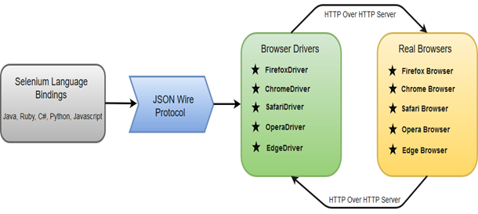

<https://www.javatpoint.com/selenium-webdriver>

<https://www.javatpoint.com/selenium-tutorial>

There are four basic components of WebDriver Architecture:

* Selenium Language Bindings
* JSON Wire Protocol
* Browser Drivers
* Real Browsers
* **Simple Commands**: Most of the commands used in Selenium WebDriver are easy to implement. For instance, to launch a browser in WebDriver following commands are used:  
  **WebDriver driver** = **new FirefoxDriver();** (Firefox browser )  
  **WebDriver driver** = **new ChromeDriver();** (Chrome browser)  
  **WebDriver driver** = **new InternetExplorerDriver();** (Internet Explorer browser)
* **WebDriver- Methods and Classes**: WebDriver provides multiple solutions to cope with some potential challenges in automation testing.  
  WebDriver also allows testers to deal with complex types of web elements such as checkboxes, dropdowns and alerts through dynamic finders.

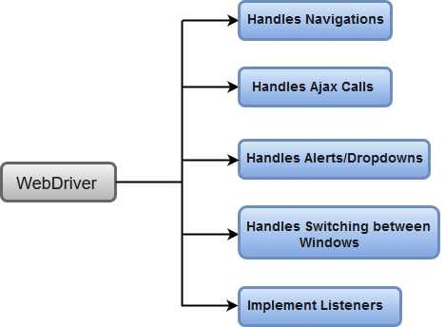

**import** org.openqa.selenium.By;

**import** org.openqa.selenium.WebDriver;

**import** org.openqa.selenium.chrome.ChromeDriver;

**public** **class** First {

**public** **static** **void** main(String[] args) {

    // declaration and instantiation of objects/variables

System.setProperty("webdriver.chrome.driver", "D:\\ChromeDriver\\chromedriver.exe");

WebDriver driver=**new** ChromeDriver();

driver.navigate().to("http://www.google.com/");

  // Click on the search text box and send value

 driver.findElement(By.id("lst-ib")).sendKeys("javatpoint tutorials");

// Click on the search button

driver.findElement(By.name("btnK")).click();

    }

}

 // System Property for Gecko Driver

    System.setProperty("webdriver.gecko.driver","D:\\GeckoDriver\\geckodriver.exe" );

         // Initialize Gecko Driver using Desired Capabilities Class

        DesiredCapabilities capabilities = DesiredCapabilities.firefox();

        capabilities.setCapability("marionette",**true**);

        WebDriver driver= **new** FirefoxDriver(capabilities);

        // Launch Website

     driver.navigate().to("https://www.testandquiz.com/selenium/testing.html");

Read once :

<https://www.javatpoint.com/selenium-webdriver-commands>

**selenium-webdriver-handling-drop-downs**

The 'Select' class in Selenium WebDriver is used for selecting and deselecting option in a dropdown. The objects of Select type can be initialized by passing the dropdown webElement as parameter to its constructor

WebElement testDropDown = driver.findElement(By.id("testingDropdown"));

Select dropdown = new Select(testDropDown);

dropdown.selectByIndex(5);   //  its index, beginning with 0

dropdown.selectByValue("Database"); // used to select an option based on its 'value' attribute.

dropdown.selectByVisibleText("Database Testing"); // used to select an option based on the text over the option

**Selenium WebDriver- Locating Strategies**

WebDriver uses the same set of locating strategies for specifying location of a particular web element.

